SITE MAP

GetO2PUK

**Table of Contents**

**1. Visit page ‘http://www.o2.co.uk/apps/getPUK/welcome’** 3

**2. ‘Support’** 4

**3. ‘General Help’** 5

**4. ‘Joining us’** 6

**5. ‘Pay monthly help’** 7

**6. ‘Pay & go help’** 8

**7. ‘Phone help’** 9

**8. ‘Our services’** 10

**9. ‘Mobile email help’** 11

**10. ‘Lost & stolen’** 12

**11. ‘O2 Family’** 13

**12. ‘O2 Joggler’** 14

**13. ‘Your Family Bolt On’** 15

**14. ‘O2 Top up Surprises’** 16

**15. ‘Unblock my mobile’** 17

**16. ‘Broadband & Internet’** 18

**17. ‘iphone help’** 19

**18. ‘O2 Money help’** 20

**19. ‘UK coverage’** 21

**20. ‘International & Travel’** 22

**21. ‘A guide to our services’** 23

**22. ‘Customer forums’** 24

**23. ‘Glossary’** 25

**24. ‘Contact Us’** 26

## **1. Visit page ‘http://www.o2.co.uk/apps/getPUK/welcome’**

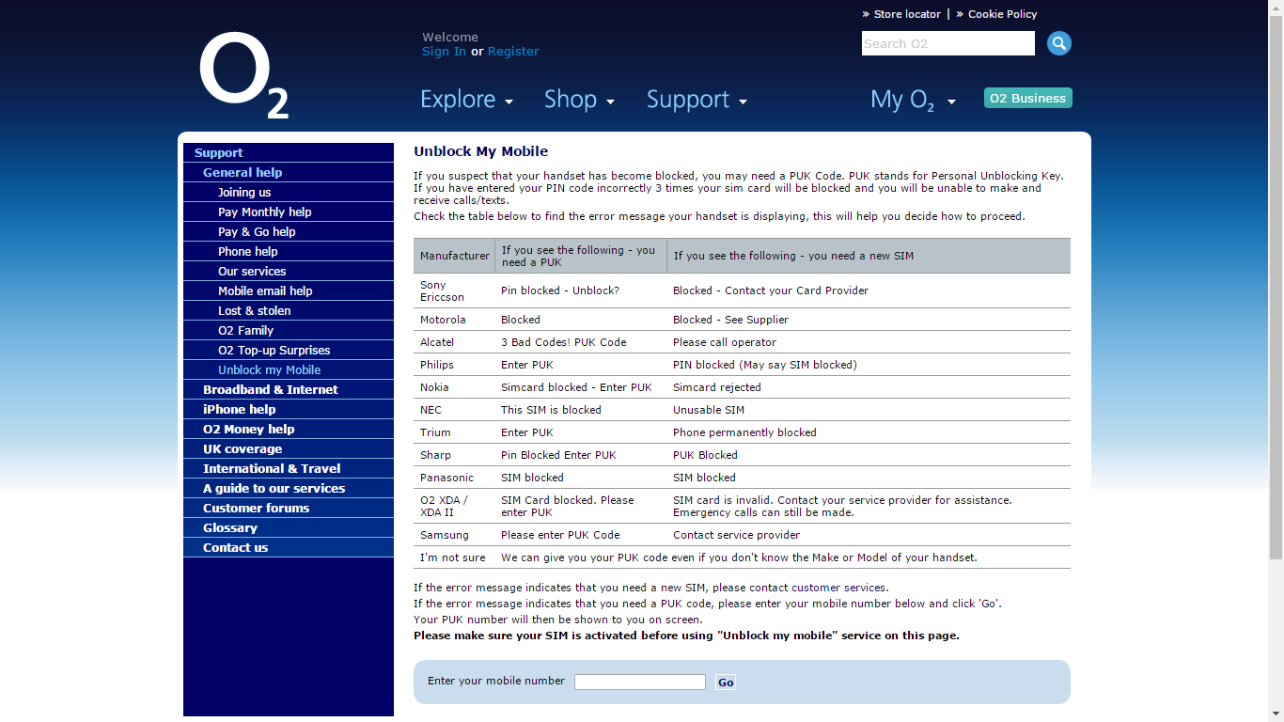

## **2. ‘Support’**



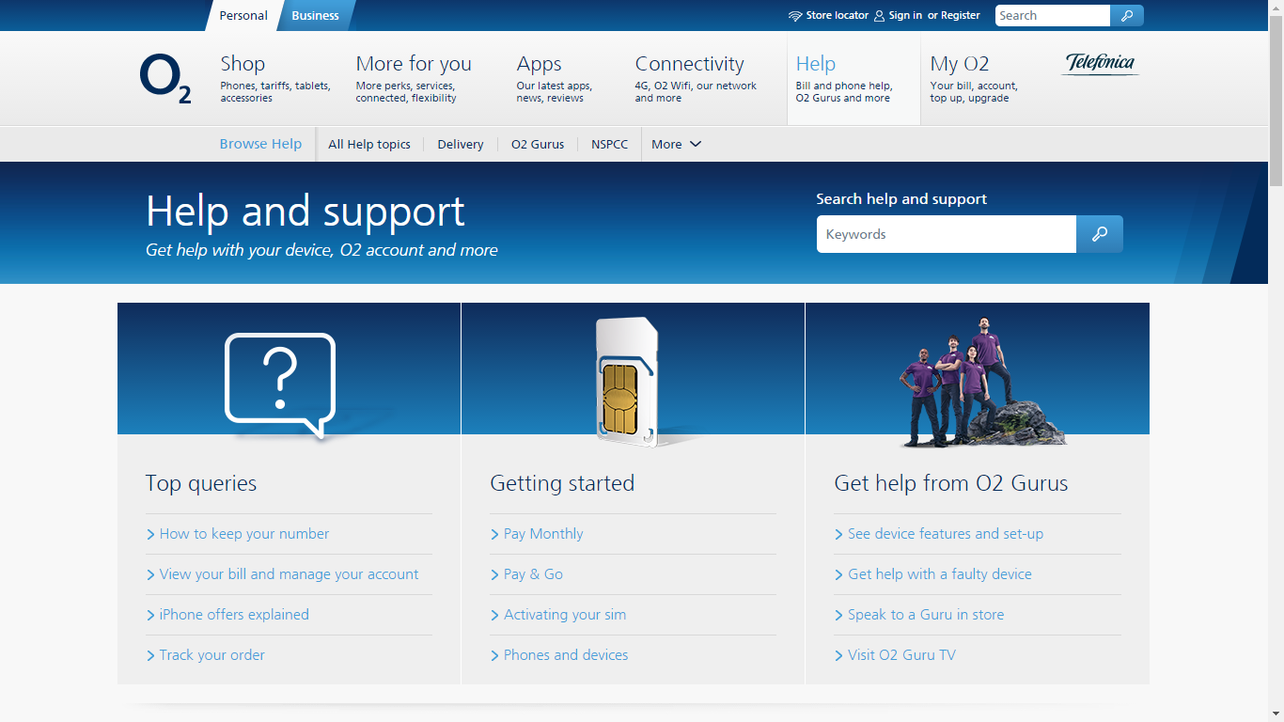

## **3. ‘General Help’**





## **4. ‘Joining us’**





## **5. ‘Pay monthly help’**



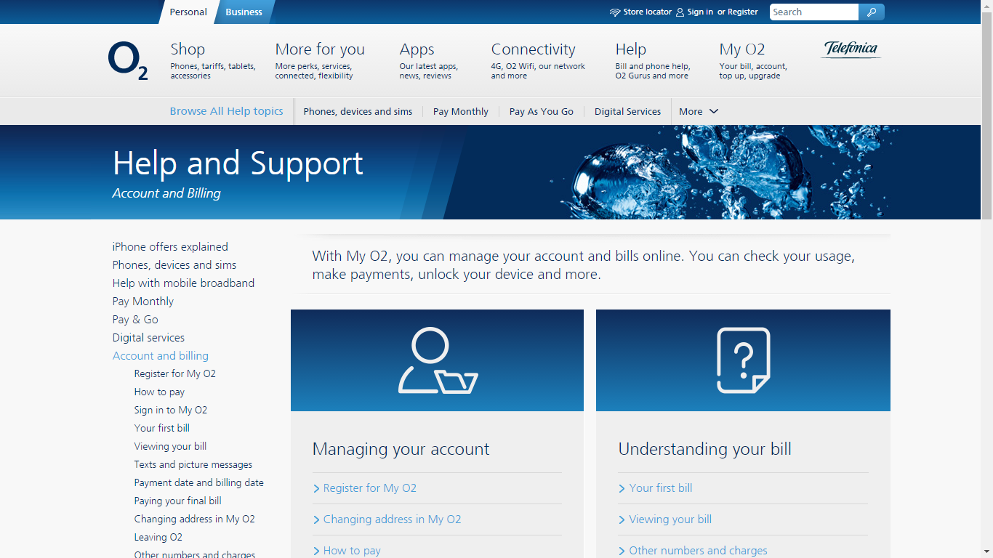

## **6. ‘Pay & go help’**



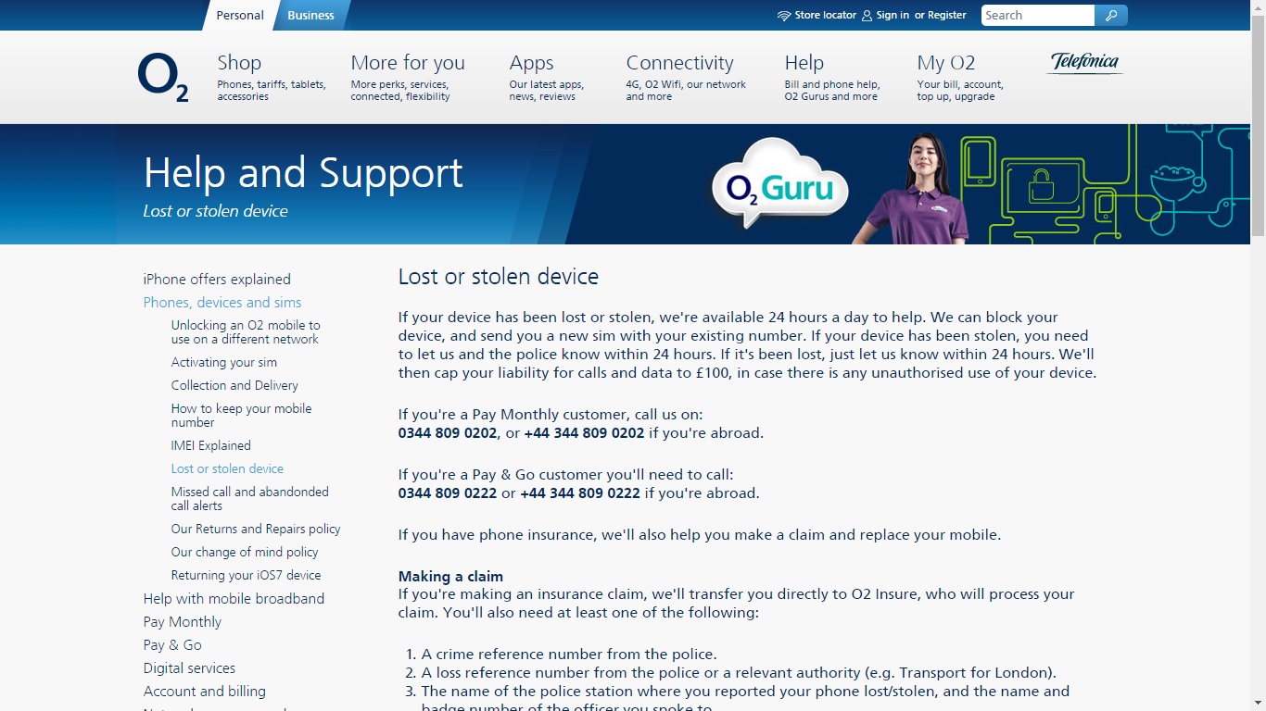

## **7. ‘Phone help’**





## **8. ‘Our services’**



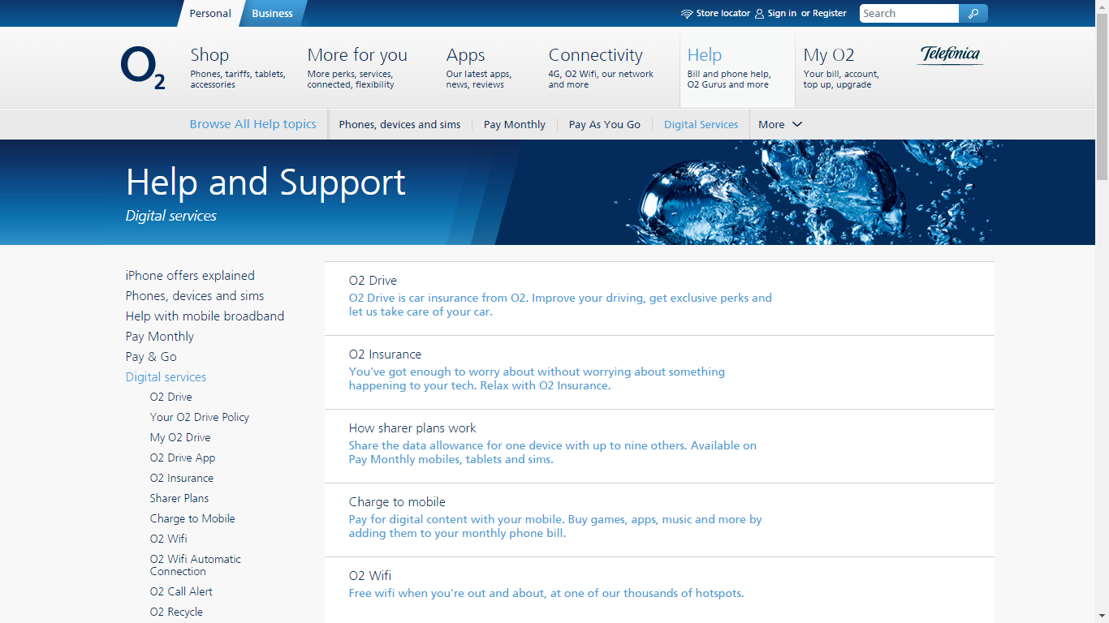

## **9. ‘Mobile email help’**



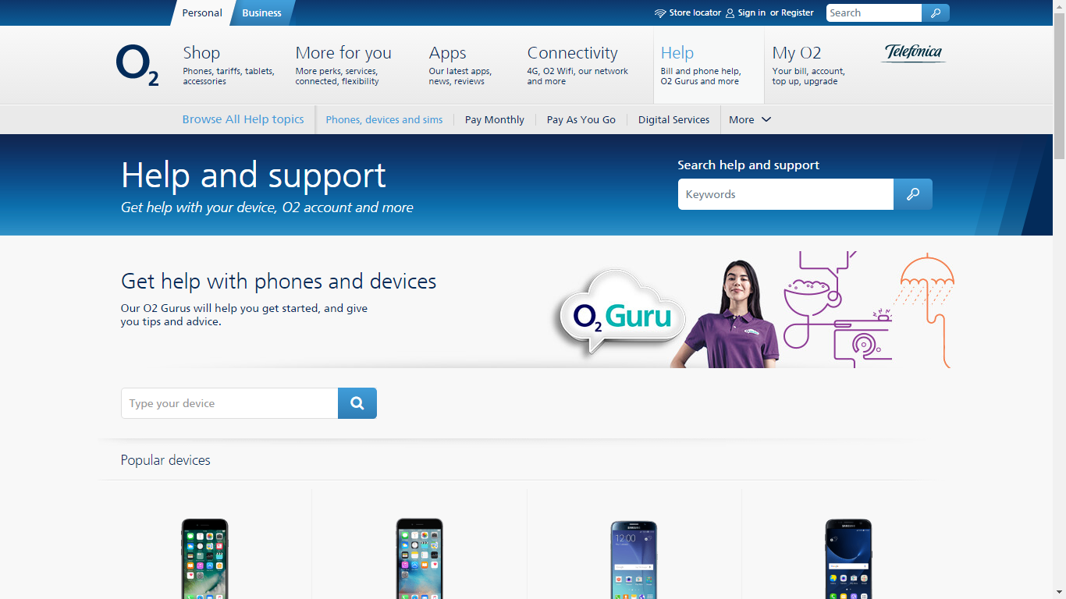

## **10. ‘Lost & stolen’**



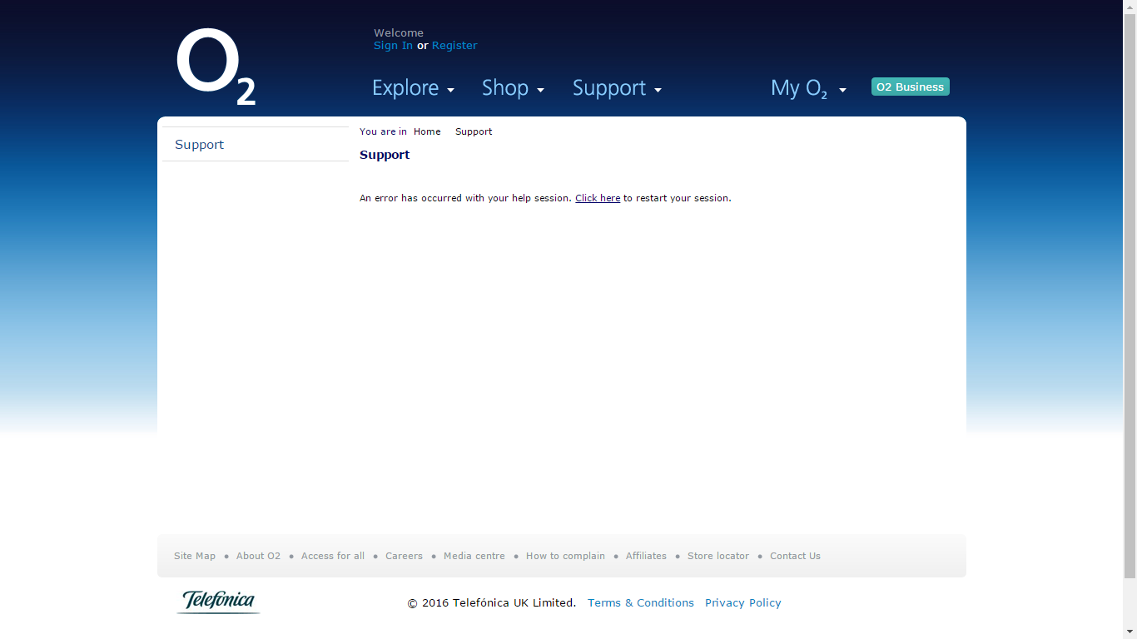

## **11. ‘O2 Family’**



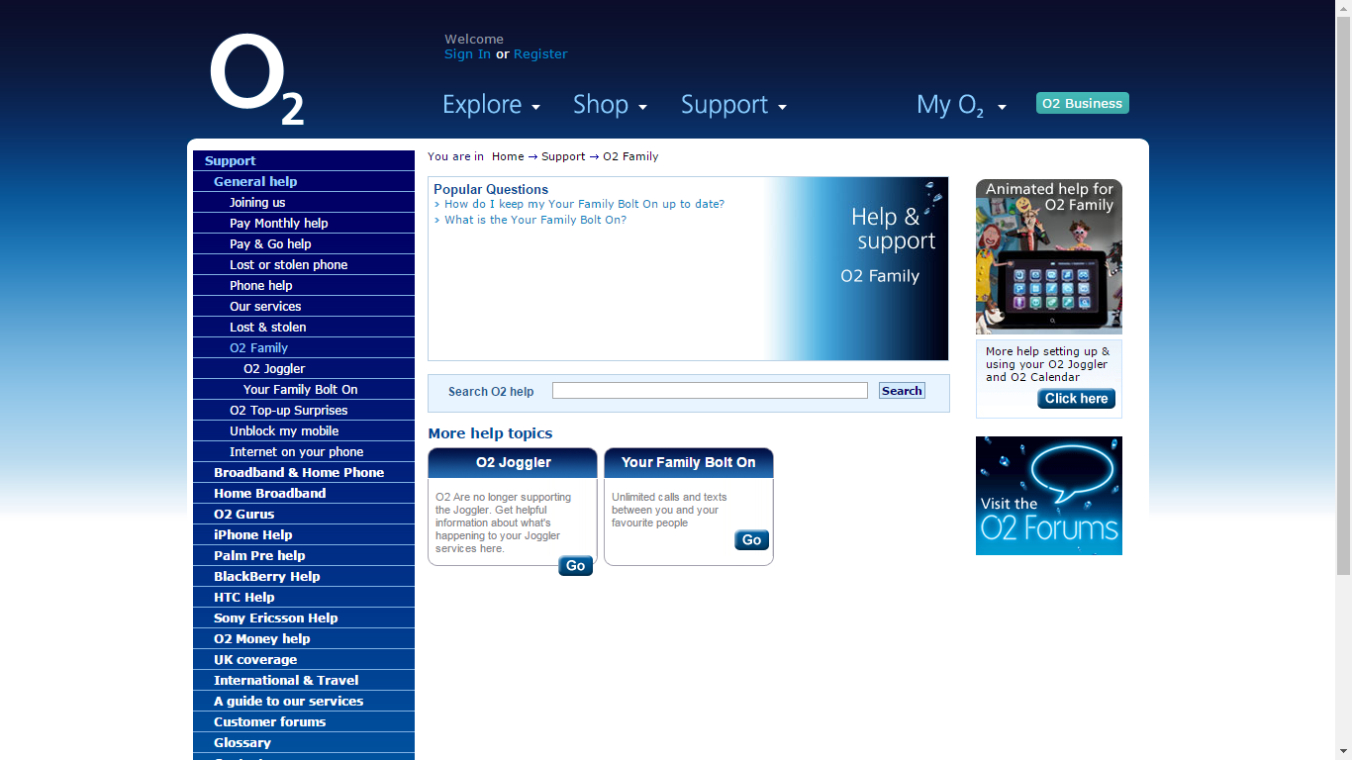

## **12. ‘O2 Joggler’**



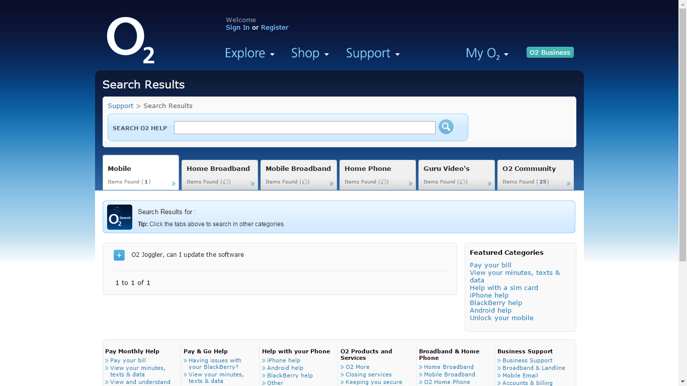

**Note**: When clicked on ‘O2 Joggler’ or ‘Your Family Bolt On’, few new options are seen as ‘Broadband & Home Phone’, ‘Home Broadband’, ‘O2 Gurus’; Help options for ‘Palm Pre’, ‘Blackberry’, HTC, Sony Ericsson.

## **13. ‘Your Family Bolt On’**



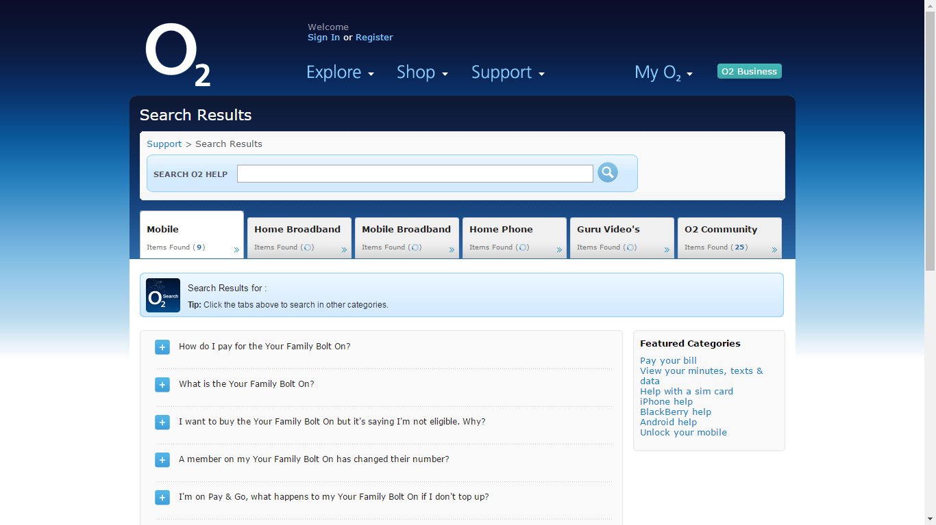

## **14. ‘O2 Top up Surprises’**



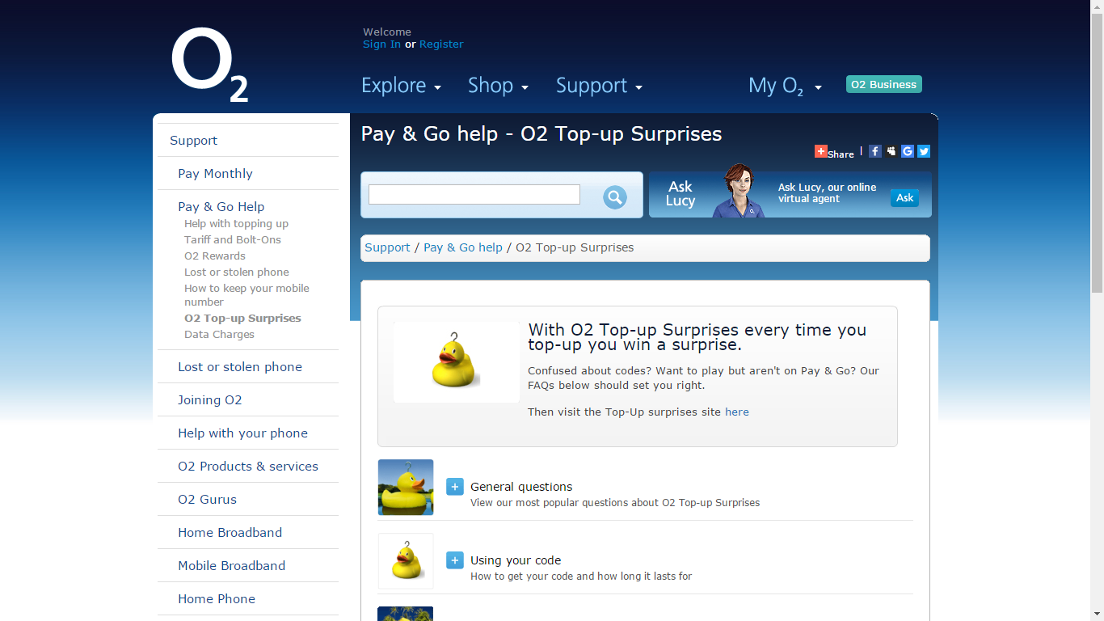

## **15. ‘Unblock my mobile’**



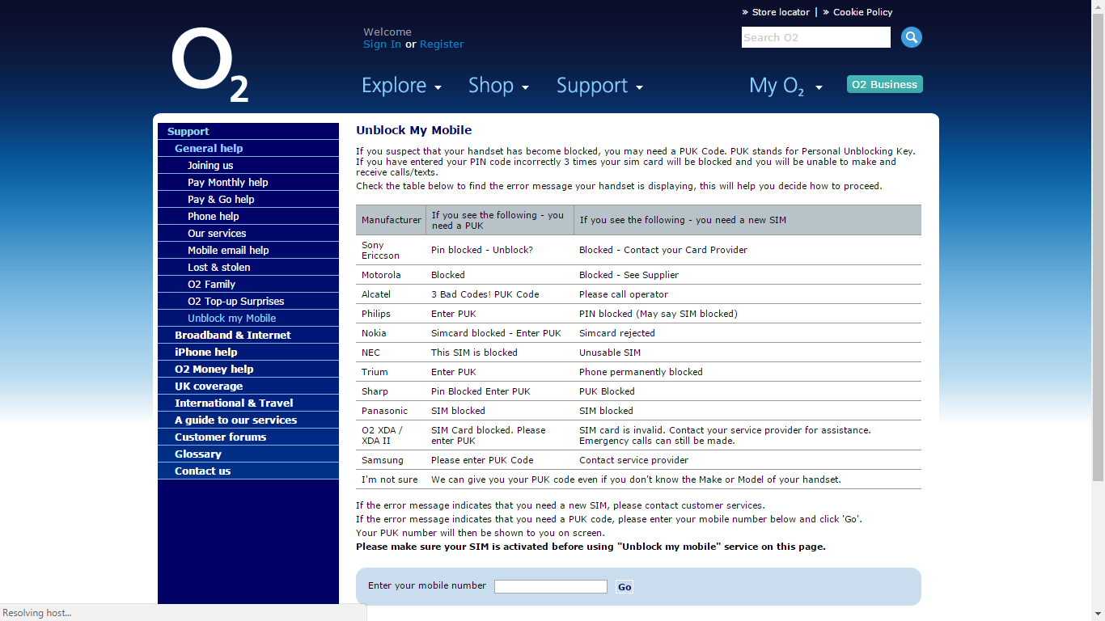

## **16. ‘Broadband & Internet’**



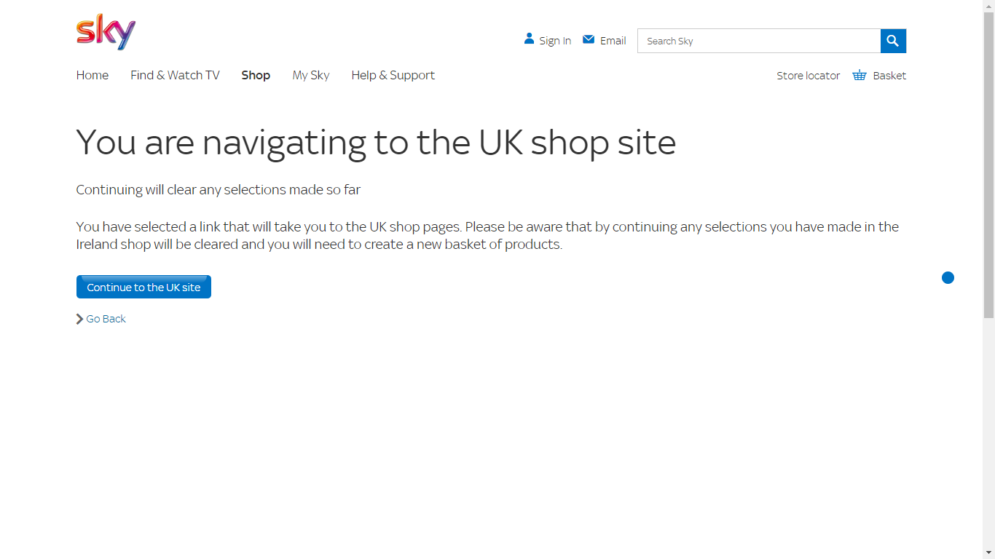

## **17. ‘iphone help’**





## **18. ‘O2 Money help’**



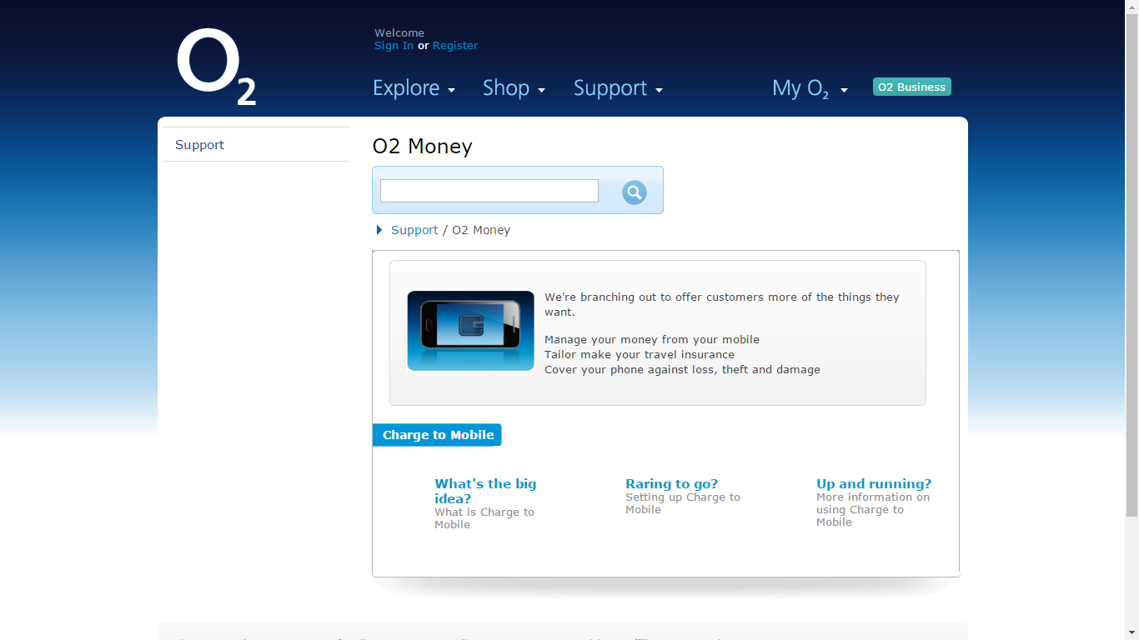

## **19. ‘UK coverage’**



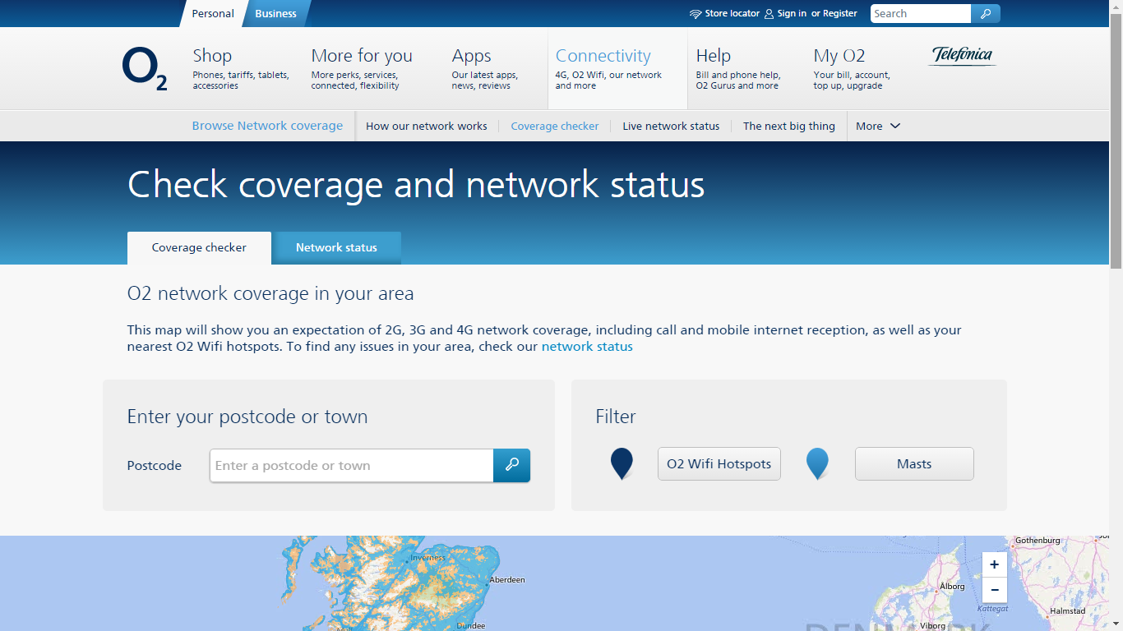

## **20. ‘International & Travel’**



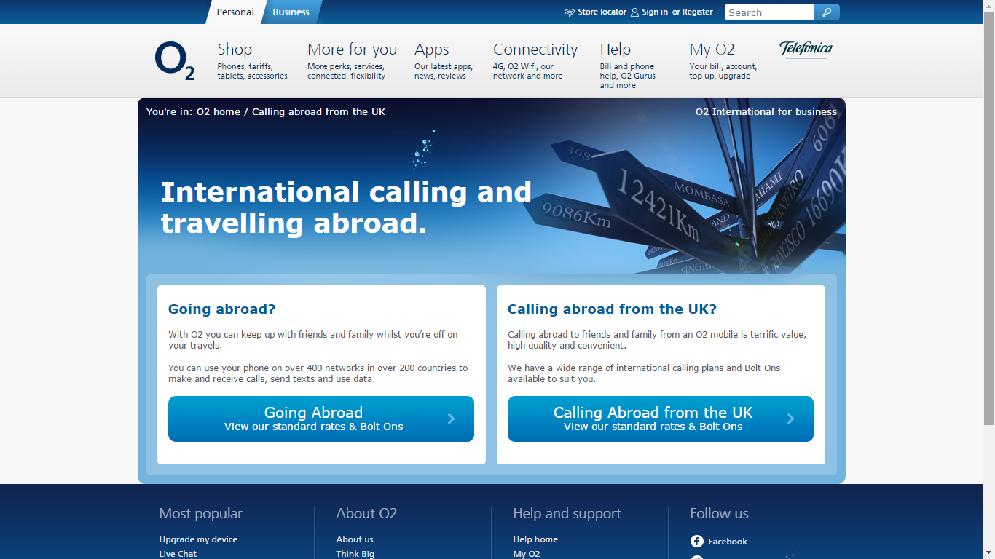

## **21. ‘A guide to our services’**



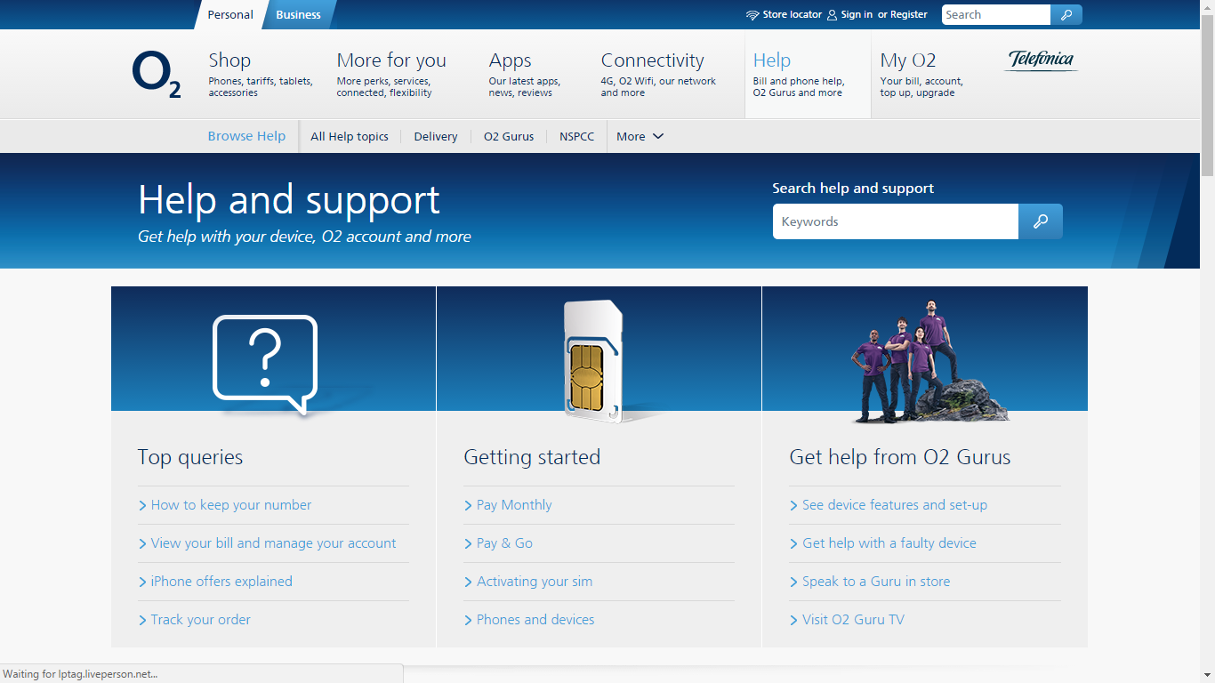

## **22. ‘Customer forums’**



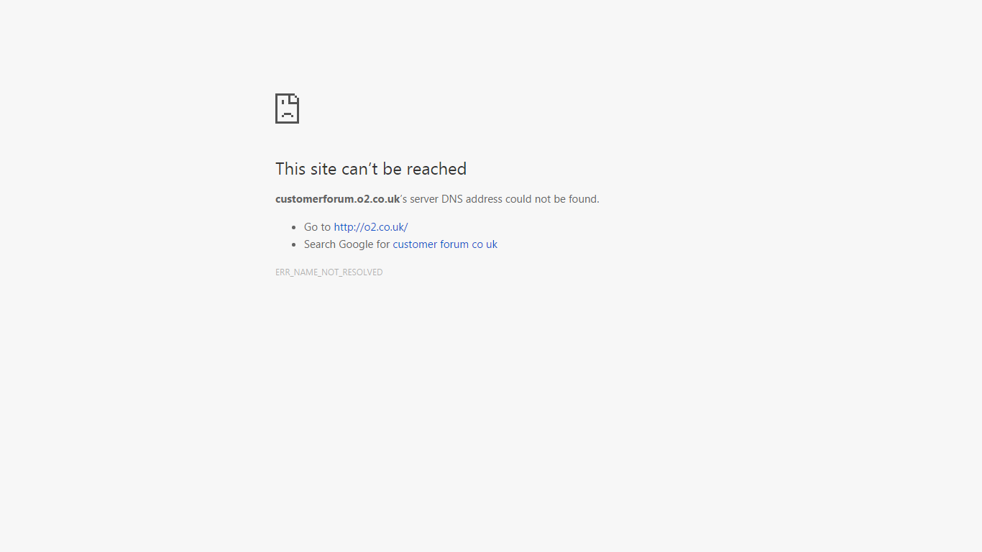

## **23. ‘Glossary’**



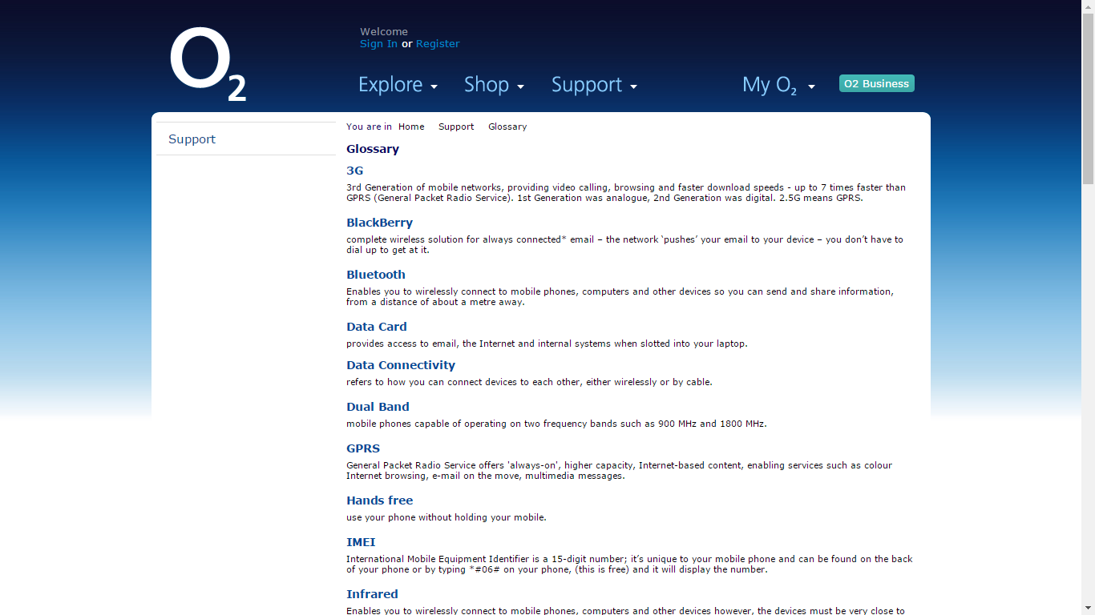

## **24. ‘Contact Us’**



